


AP Pre-Calculus

Elkins High School

Mrs. Warren
Email: xiaojuan.warren@fortbendisd.gov

Course Description:

In this AP Pre-Calculus course, students explore all high school Pre-Calculus topics as well as advanced Algebra and Geometry concepts. This class requires students to demonstrate fluent understanding of concepts and procedures, reason abstractly and quantitatively to solve problems, communicate reasoning, model with mathematics, and evaluate conclusions. As in all advanced level courses, students are expected to complete work according to given timelines so they are prepared to move through the curriculum at the required pace. Students who successfully complete this course will be prepared for Calculus I.

Topics:
Semester 1: Polynomial, Rational, (AP exam 30-40%) Exponential and Logarithmic Functions (AP exam 27-40%)
Semester 2: Trigonometric and Polar Functions, (AP exam 30-35%) Functions involving Parameters, Vectors and Matrices (Not Tested)

Expectations for all students:
1. Stay organized and keep all assignments and assessments. If you think something has been graded incorrectly, show Mrs. Warren immediately.
2. Check the calendar and Schoology for notes, practice material and keys when absent. You are still responsible for the material.
3. Missing test or quiz due to absences immediately prior to the assessments need to be made up within number of days of absences.

Grading: Daily (Test reviews, daily assignments, and quizzes): at least 6 grades per term @ 50%
Major (Tests and Projects): at least 3 grades per term @ 50% (AP exam score is also part of grade)

Progressive Testing: For each term, first test grade can be replaced by second test grade if better and second test grade can be replaced by third test grade if better, but third test grade stands as is with an opportunity to retest for a max grade of 75. Each consecutive test will be 1/3 previous test material and 2/3 current test material.

AP Pre-Calculus Essentials:
- AP Classroom (Resource)
- Mathematical Practices (Exam question types):
1. Procedural and symbolic fluency: Algebraically manipulate functions, equations, and expressions
2. Multiple Representations: Translate mathematical information between representations.
3. Communication and Reasoning: Communicate with precise language and provide rationales for conclusions.
- Structured Communication: precisely written work procedure (complete sentences)

- Increased Reading Comprehension.
- Better Collaboration
- The details of the exam, including exam weighting, timing, and calculator requirements:

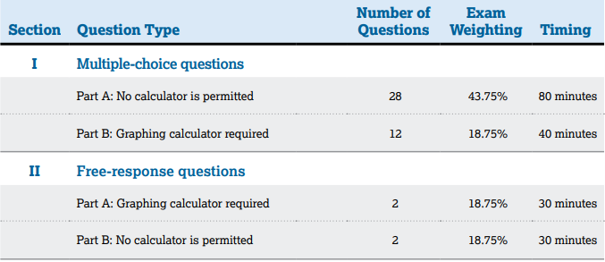

Materials:
School laptop
TI-Nspire graphing calculator (for home use & optional)
Writing utensil of your choice
Spiral notebook with graph paper (if possible)
Folder for homework

Tutorials: Mondays from 2:55-4:00 pm
Tuesdays from 2:55-4:00 pm
Morning Tutorial by appointment

Contacting Me:

If you have any problems or concerns that you would like to discuss, please contact me.
Email: xiaojuan.warren@fortbendisd.gov (you can also access this through the school website)
Phone: 281-634-2600 (front office), 281-634-2654 (room phone, please leave a message)
My conference is 4th period (look at weekly schedule for time)

Let’s work together to make this a great year!

